Probability and statistics Worksheet Yr 9 Maths

1 Consider the set of data:

23, 17, 19, 24, 28, 25, 16, 24.

a Find the mean of this set of data.

b Find the median of this set of data.

c Find the mode of this set of data.

d Determine the data value that needs to be added to this data to make the mean decrease by one.

e When the data value found in part d is included, what is the new median?

2 Consider the following data set:

45 32 43 29 17 38 41 37
20 41 37 41 46 34 25

a Organise the data into an ordered stem-and-leaf plot.

Stem | Leaf

b Find the median.

c Find the mode.

d Describe the data as symmetrical or skewed.

3 The stem and leaf diagram below shows the age of 19 members of a bowls club.

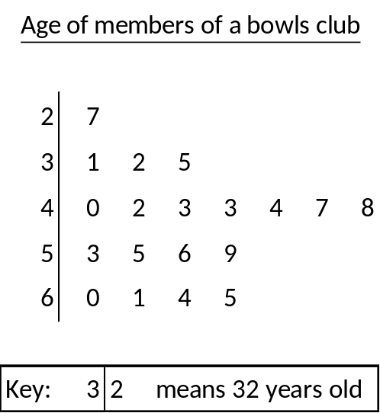
a) How old was the oldest member of the bowls club?

b) How old was the youngest member of the bowls club?

c) What was the range of the ages of the members of the bowls club?

d) What was the modal age of the members of the bowls club?

e) What was the median age of the members of the bowls club?

f) Describe the distribution of the data set

